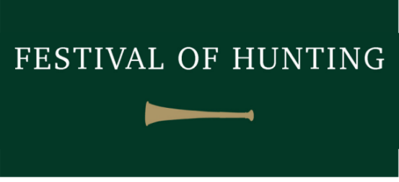
Inter Hunt Team Relay 2023
Results

Senior Relay Teams

1st ^{Quorn Hunt}
2nd ^{Blankney Hunt}
3rd ^{Duke of Beaufort Hunt}
4th ^{Fernie Hunt}
5th ^{Ashford Valley Tickham Hunt}
6th ^{Puckeridge} ^{& Essex Hunts}
7th ^{Teme Valley Hunt}
8th ^{Puckeridge} ^{& Essex Hunts}

Junior Relay Teams

1st ^{Grove & Rufford Hunt - Team 1}
2nd ^{Duke of Beaufort Hunt}
3rd Woodland Pytchley Hunt PC – Team 1
4th ^{Staff College Drag Hunt}
5th ^{Teme Valley Hunt}
6th ^{Holcombe Harriers}
7th Woodland Pytchley Hunt PC – Team 2
8th ^{West Norfolk Foxhounds}

With special thanks to the following for supporting the Inter Hunt Team Relay

GLATTON SERVICES
Equestrian Paddock Maintenance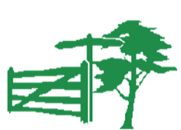
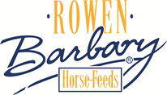
The Reynolds Family

