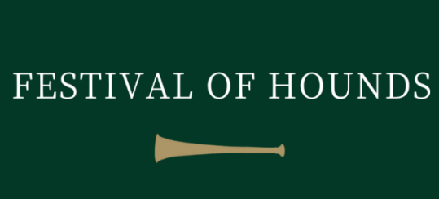

FESTIVAL OF HOUNDS 17th JULY 2024.
Ring Supported by

Senior Team Results

1st Quorn Hunt - Bib 7
2nd Southdown & Eridge with East Sussex & Romney Marsh Hunt – Bib 18
3rd Grafton Hunt - Bib 1
4th Staff College Drag Hunt – Bib 11
5th Duke of Beaufort Hunt – Bib 13
6th VWH Hunt – Bib 14
7th Belvoir Hunt – Bib 10
8th Puckeridge with Essex Hunt – Bib 2

Junior Team Results

1st The Belvoir Divas – Bib 1
2nd Holcombe Harriers – Bib 14
3rd Teme Valley Hunt – Bib 6
4th Quorn Hunt Pony Club – Bib 23
5th West Norfolk Foxhounds – Bib 4
6th Duke of Beaufort Hunt – Bib 21
7th Meynell Pony Club – Bib 11
8th Grove & Rufford Hunt - Bib 15

With special thanks to the following for supporting the Inter Hunt Team Relay

GLATTON SERVICES
Equestrian Paddock Maintenance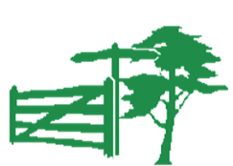
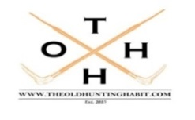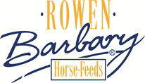
The Reynolds Family

